

REPUBLIC OF ALBANIA

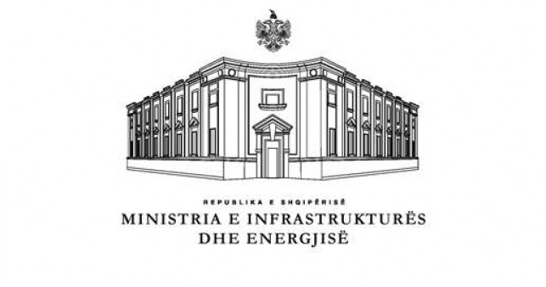

MINISTRY OF INFRASTRUCTURE MINISTRY OF FINANCE AND
AND ENERGY ECONOMY

NOTICE ON THE COMPETITIVE PROCEDURE FOR THE SELECTION OF PARTICIPANTS IN THE MARKET OPERATOR SHARE CAPITAL

- Name and address of the Special Commission
Name Special Commission
Address Ministry of Infrastructure and Energy, Str. “Abdi Toptani”, No.1, Tirana, Albania
Tel/Fax +355 4 2222245
Website www.infrastruktura.gov.al
Contact person: Kledia Ngjela - Kledia.Ngjela@infrastruktura.gov.al

- Short Description of the Object of the Selection Procedure: Pursuant to Article 57 of Law no. 43/2015, “On power sector”, as amended, DCM no. 322, dated 15.05.2019 and DCM No. 609, dated 11.09.2019, it is decided to establish the Market Operator (Albanian Power Exchange), as the responsible structure for the management and administration of the organized market, through the market platform, which will operate in the field of electricity exchange in Albania, in the form of a joint stock company, financially and legally separated from Transmission System Operator (“Operatori i Sistemit të Transmetimit" sh.a.).

The selection of other legal entities that will become part of the ownership structure of the Market Operator (excluding the Transmission System Operator - “Operatori i Sistemit të Transmetimit" sh.a. - OST sh.a.) will be selected, through the competitive selection procedure, by the Special Commission set up by the Minister of MIE and Minister of MFE.

The initial share capital of the company shall be 250.000.000,00 (two hundred and fifty million) ALL and is divided 250.000,00 (two hundred and fifty thousand) shares with a nominal value of 1,000.00 (one thousand) ALL. Every share has equal value.

The number of shares available to entities/subjects that may be part of the Market Operator's share capital ownership structure shall be:

- Electricity Transmission System Operators - TSOs (excluding OST sh.a.) - 51.250,00 (fifty one thousand two hundred and fifty) shares (equivalent to 20,5% of the share capital)

- Experienced International Operators - EIOs – 61.250,00 (sixty-one thousand two hundred and fifty) shares (equivalent to 24,5% of the share capital);

- Electricity Market Participants - EMPs – 25.000,00 (twenty-five thousand) shares (equivalent to 10% of share capital);

d) International Financial Institutions - IFIs – 25.000,00 (twenty-five thousand) shares (equivalent to 10% of the share capital).

Each participant must submit only one proposal for one of the aforementioned categories.

Number of shares reserved for the Transmission System Operator (OST sh.a.). - OST sh.a. - 87.500,00 (eighty-seven thousand five hundred) equivalent to 35% of the capital of the Market Operator company. Subject to the development of a competitive selection procedure for participants in the Market Operator's capital, this percentage shall be increased in accordance with the provisions of these Documents of the Competitive Selection Procedure and DCM No. 609, dated 11.09.2019.

- The deadline for the submission of proposals by the parties interested to participate in the procedure: Date 27/04/2020, for each participant according to the categories they participate in, the schedule will be as follows:

International Financial Institutions - IFIs 12:00 p.m.
Experienced International Operators - EIOs 12:30 p.m.
Electricity Transmission System Operators - TSOs 13:00
Participants in the Electricity Market - PEMs 13:30

- Deadline for the opening of proposals by the parties interested to participate in the procedure: Date 27/04/2020, for each participant according to the categories they participate in, the schedule will be as follows:

International Financial Institutions - IFIs 12:00 p.m.
Experienced International Operators - EIOs 12:30 p.m.
Electricity Transmission System Operators - TSOs 13:00
Participants in the Electricity Market - PEMs 13:30

- Payment of the participation fee in the competitive procedure: Participants in the procedure wishing to participate in the Competitive Selection Procedure shall pay in advance a Participation Fee (the "Participation Fee") and shall provide the Special Commission with the details of a contact person ("The Contact Person of the Participant in the Procedure") and the e-mail address of this Contact person, this address will be used by the Special Commission in all and any correspondence with the Participant in the procedure and related notices, for the period up to the submission of the proposal. Participants in the procedure will be required to prove payment of the Participation Fee in the Competitive Selection Procedure, stating the name of the Participant in the procedure on whose behalf this fee is paid. This Participation Fee is not refundable for any reason. If the interested person/entity acts as an authorized representative of a company, they must submit a written authorization representing the company.

The Special Commission shall make available to entities that have paid the participation fee a copy of the Competitive Process Documents in Albanian or English upon their written request. The fee to participate in the competitive process is 1 000 EURO (one thousand EURO). The payment will be made to the Transmission System Operator's account, in the following details:

Name of Beneficiary Institution: | Operatori i Sistemit të Transmetimit (Transmission System Operator)
Account Name:  Bank:  SWIFT: | IBAN: AL63212110160000000000142152  Credins Bank  CDISALTR
Purchase of documents for the procedure: | Selection of other legal entities that will become part of the ownership structure of the Market Operator, according to the shareholder structure defined in DCM no. 322, dated 15.5.2019 "On the establishment and definition of the legal form and of the ownership structure of the market operator’s share capital" and DCM no. 609, dated 11.9.2019 "On defining the criteria and procedures for the selection of participants in the market operator's share capital"
With the description: | Payment of the Participation Fee in the Competitive Selection Procedure for the Selection of Other Legal Entities that will become part of the Market Operator's Share Capital Ownership Structure
The fee for participation in the competitive process is non-refundable.

Only participants that have paid the Participation Fee will be eligible to receive copies of the Competitive Selection Documents and will be eligible to participate in the Procedure.

- The competitive process documents may be withdrawn from the above mentioned entities/subjects starting from 03.03.2020 from 9:00 to 14:00, any day of the week, except Saturdays and Sundays, at the Protocol Office at the headquarters of the Transmission System Operator OST sh.a., at the below address: Autostrada Tirane –Durrës, km 9, Yrshek –Kashar, Tirana, Albania.

