SPECIFICATIONS OF OPERATIONAL RULES
Final Draft 17.10.18

Table of Contents
1 PURPOSE 4
2 SYSTEM BALANCING 4
2.1 Energy Nominations Process 4
2.1.1 Nomination process 4
2.1.2 Nomination gate closures 7
2.1.3 Communication process – actors and messages 7
2.1.4 Ex-ante nominations 7
2.1.5 Ex-post nominations 7
2.1.6 Fall-back 7
2.2 Exchange process of measurement data 7
2.3 Imbalance price calculation 8
2.3.1 Definitions 8
2.3.2 Specification of regulation states (per ISP) 8
2.3.3 Specification of imbalance price 9
3 QUALIFICATION 10
3.1 Prequalification process 10
3.1.1 Supplier of balancing services 10
3.1.2 Input 10
3.1.3 Process 11
3.1.4 Output 12
3.2 FCR provider qualification 12
3.2.1 Technical criteria 12
3.2.2 Prequalification tests 14
3.2.3 Synthetic Frequency Profile (SCF) test 14
3.2.4 Real-time frequency test 17
3.2.5 Calculation of FCR_{max} 17
3.3 aFRR provider qualification 18
3.3.1 Technical criteria 18
3.3.2 Prequalification test 18
3.4 mFRR/RR provider qualification 20
3.4.1 Technical criteria 20
3.4.2 Prequalification test 20
3.5 ER provider qualification 20
3.5.1 Technical criteria 21
3.5.2 Prequalification test 21
3.6 Fall-back 21
4 AVAILABILITY COMMITMENT PROCESS. 22
4.1 Participant registration and mutation process 22
4.2 Dimensioning and sizing 22
4.2.1 FCR 22
4.2.2 aFRR 23
4.2.3 mFRR 23
4.2.4 RR 23
4.2.5 Emergency reserves 23
4.3 Bidding process 24
4.4 Selection process 24
4.5 Pricing 25
4.6 Results publication 25
4.7 Timings 25
4.8 Fall-backs 26
5 DELIVERY COMMITMENT PROCESS 26
5.1 Bid specification 26
5.1.1 Bid categories 26
5.1.2 Structure of a delivery commitment bid message 27
5.1.3 Attributes of a bid message 27
5.1.4 Attributes of a delivery commitment bid 27
5.1.5 Attributes of a delivery commitment bid line 28
5.1.6 Optional aspects of attributes 29
5.2 Bidding gate closures 30
5.2.1 Before the day of delivery 30
5.2.2 During day of delivery 30
5.3 Results publication 30
5.4 Timings 30

PURPOSE
1.1 This document is a supplementary document attached to the Balancing Market Rules. The purpose of this document is to clarify all processes that are implemented in the Balancing Market based on detailed activity sequence description, specifications of activities, and the timing of each activity.

SYSTEM BALANCING

Energy Nominations Process

Nomination process

2.1.1.1 Supplier: BRPs
- Input information: Cross-zonal trades, e.g. for each ISP of the day of transaction
  - Nominating BRP
  - Contract number of the allocated cross-zonal capacity rights
  - Foreign bidding zone
  - Nominated BRP (i.e. foreign BRP, must have BRP recognition from foreign TSO)
  - The volume of nominated capacity rights for the transaction concerned
  - The direction of the nomination
- Intra-zonal trades, e.g. for each ISP of the trade on the day of transaction
  - Nominating BRP (any BRP with trade or full recognition)
  - Nominated BRP (any BRP with trade or full recognition)
  - Energy transferred
  - Direction of energy transfer
- Intra-zonal grid exchanges
  - Nominating BRP (full recognition only)
  - Day of nomination
  - For each Connection Point and ISP
iii.1 ISP
iii.2 EIC of connection point
iii.3 Nominated grid exchange volume
iv.1 Direction of nominated grid exchange volume
2.1.1.2 Process: (note: all timings are local Albanian time)
- BRPs who own long-term transmission rights submit the transactions they want to do making use of those rights no later than 9h00 before the day of transactions. This shall be done through a standard electronic message.
- In case a BRP misses a long term capacity nomination deadline, TSO shall not acknowledge any cross-zonal nominations that make use of these capacity rights
- The TSO informs the market on acknowledged cross-border nominations of long term allocated capacity rights and the remaining cross-border capacity available for day ahead market coupling no later than xxh00 ( TSO to fill in, usually at least 1 hour ahead of day-ahead market gate opening)
- All long term and day ahead cross-border nominations and all intra-zonal nominations resulting from the day-ahead market shall be submitted before 14.00 on the day before the day of transaction
- Approval requirements of energy nominations by a BRP:
  - The TSO can withhold approval of a nomination if they are internally not consistent or externally not consistent
i.1. Internal consistent means:
i.1.1. For a BRP with full recognition:
Per imbalance settlement period the nominated grid take-offs plus the nominated sales to other BRPs plus the nominated exports are in balance with the nominated grid in-feeds, the nominated purchases from other BRPs and the nominated imports
i.1.2. For a BRP with trade recognition:
Per imbalance settlement period the nominated sales to other BRPs plus the nominated exports are in balance with the nominated purchases from other BRPs and the nominated imports
i.2. External consistent means:
All information on a transaction is consistent with any information on the same transaction from relevant other BRPs.
For cross-zonal transaction this means that the TSO will have to check with the foreign TSO concerned the external consistency: BRPs on both sides must have nominated the same amount to the other BRP but in a different direction.
In case of conflicts in external consistencies of transactions between two BRPs, the smallest nominated volume of trade will be applied and the BRPs informed accordingly.
In case of external inconsistencies concerning transactions with the PX BRP, the PX nominations will prevail. The BRPs concerned will be informed accordingly so that they can adjust their grid exchange nominations to be in balance with the adjusted trade nominations (if needed).
  - In case of non-approval the TSO informs the BRPs concerned and the BRPs concerned submit improved nominations as soon as possible, which again require approval by the TSO
- Approved nominations enter into force on 0h00 of the day concerned
- Changes in nominations:
  - Changes can be submitted until 10h00 after the day of transaction (D+1, 10h00)
  - In case of changes, the whole nomination for the day concerned must be re-send. If approved, the new nomination replaces the old one. The new nomination cannot be partially approved
  - Changes must be approved by the TSO if (note: this means they can be rejected otherwise):
iii.1. It concerns intra-zonal transactions and the changes submitted by all BRPs involved are consistent
iii.2. It concerns cross-zonal transactions and the changes submitted are confirmed by the TSO on the other side of the border or by the concerned capacity platform that operates on behalf of that TSO and the changes are submitted no later than one clock hour before the hour of transaction
2.1.1.3 Output:
- Approved cross-zonal and intra-zonal nominations of all BRPs
- Nominated net position per ISP per BRP (for imbalance settlement purposes), sum of approved
  - - Nominations of grid extractions on each connection point of the BRP
  - + Nominations of grid infeeds on each connection point of the BRP
  - – cross-zonal export nominations on all zone borders
  - + cross-zonal import nominations on all zone borders
2.1.1.4 Clients:
- BRPs

Nomination gate closures
2.1.2.1 9h00 D-1: Cross-zonal nominations of long term capacity rights
2.1.2.2 14h00 D-1: Intra-zonal and cross-border nominations
2.1.2.3 H-1: Changes in cross-zonal nominations (e.g. intraday)
2.1.2.4 D+1, 10h00: Intra-zonal nominations

Communication process – actors and messages
2.1.3.1 Actors are the BRPs and the TSO.
2.1.3.2 From the forgoing description, required communication messages can be derived and developed into a business process sequence diagram as an aid for the gap analysis with the DAMAS system to be performed by the TSO. The business process sequence diagram, if needed, shall also be developed by the TSO.

2.1.3.3 Non-exhaustive list of messages consists of:
- Initial nomination submission message
- Nomination re-submission message (e.g. after rejection or communication error)
- Nomination change message
- Nomination approval message
- Nomination rejection message

Ex-ante nominations
2.1.4.1 Initial nominations for cross-zonal transactions using allocated long term capacity rights and nominations for intra-zonal transactions and cross-zonal transactions resulting from the day ahead market (coupling) must be submitted on D-1 before 14h00.
2.1.4.2 Incremental nominations are described as change in nominations above. Incremental nominations for cross-zonal transactions may be submitted up to one hour before the hour of the transaction.

Ex-post nominations
2.1.5.1 Only intra-zonal nominations shall be accepted ex-post. Final gate closure time for intra-zonal nominations is D+1, 10h00.

Fall-back
2.1.6.1 In case the electronic messaging system via a central postbox does not function or the BRP has temporarily no access to the system, an emergency procedure may allow BRPs to submit the nominations/re-nominations by way of regular e-mail subject to format requirements to be specified by the TSO.

Exchange process of measurement data
2.2.1 Regarding the real-time data exchange between the SCADA systems of the BSP and the TSO, the following information exchange shall apply:
- Measurements that determine the reference signal of aFRR providing units.
- Measurements of real-time output.
- Changes of the total reserve power are real-time communicated by the TSO. It shall be electronically recorded by the TSO and by The BSP.
- The BSP sends the signal back to the TSO (mirror of the received signal) in order to check if the signal is received correctly.
- The following information comes from each BSP unit to the TSO.
- A logical signal (0 or 1) that indicates whether the BSP Unit (or if applicable Power Plant) is actually participating in the Service.
- Type of balancing service product and the direction.
- The number of MW of the total reserve power change requested by the TSO that are attributed to a unit.
- The reference power (in MW) that each BSP Unit of the BSP participating in the delivery commitment shall inject in t + ∆ts for The BSP’s own needs.
- Minimum/Maximum power of the BSP Unit.
- Maximum ramping rate of the BSP Unit
- The measurement of the net (gross if the net value cannot be measured) power produced per BSP Unit.

Imbalance price calculation

Definitions
2.3.1.1 Upwards regulation
2.3.1.2 Downwards regulation
2.3.1.3 Price for upwards balancing energy
2.3.1.4 Price for downward balancing energy
2.3.1.5 Incentive component
2.3.1.6 Regulation state (of the system)
2.3.1.7 Balance delta: proxy for system imbalance to be published in real-time by the TSO (open loop ACE)
2.3.1.8 Mid-price: definition of the balancing energy price in case of no regulation

Specification of regulation states (per ISP)
2.3.2.1 no upwards nor downwards regulation requested: regulation state = 0
2.3.2.2 only upwards regulation requested: regulation state = +1
2.3.2.3 only downward regulation requested: regulation state = -1
2.3.2.4 both up- and downward regulation requested but the balance delta has been continuously non-decreasing: regulation state = +1
2.3.2.5 both up- and downward regulation requested but the balance delta has been continuously non-increasing: regulation state = -1
2.3.2.6 both up- and downward regulation requested but the balance delta has neither been continuously non-increasing nor continuously non-decreasing: regulation state = 2
2.3.2.7 both up- and downward regulation requested but the balance delta has been continuously non-increasing and continuously non-decreasing: regulation state = 2

Specification of imbalance price
2.3.3.1 Imbalance price in case of regulation state = -1 (system surplus)
- If the BRP imbalance implies extraction from the grid (BRP shortage), the imbalance price is equal to the price for downward balancing energy plus the incentive component. In this case the BRP pays to the TSO
- If the BRP imbalance implies feed-in into the grid (BRP surplus), the imbalance price is equal to the price for downward balancing energy minus the incentive component. In this case the TSO pays to the BRP
2.3.3.2 Imbalance price in case of regulation state = +1 (system shortage)
- If the BRP imbalance implies extraction from the grid (BRP shortage), the imbalance price is equal to the price for upward balancing energy plus the incentive component. In this case the BRP pays to the TSO
- If the BRP imbalance implies feed-in into the grid (BRP surplus), the imbalance price is equal to the price for upward balancing energy minus the incentive component. In this case the TSO pays to the BRP
2.3.3.3 Imbalance price in case of regulation state = 2 (dual system imbalance)
- If the BRP imbalance implies extraction from the grid (BRP shortage) and the mid-price is higher than the price for upward balancing energy, the imbalance price is equal to the mid-price plus the incentive component. In this case the BRP pays to the TSO
- If the BRP imbalance implies feed-in into the grid (BRP surplus) and the mid-price is lower than the price for downward balancing energy, the imbalance price is equal to the mid-price minus the incentive component. In this case the TSO pays to the BRP
- If the BRP imbalance implies extraction from the grid (BRP shortage) and the mid-price is not higher than the price for upward balancing energy, the imbalance price is equal to the price for upward balancing energy plus the incentive component. In this case the BRP pays to the TSO
- If the BRP imbalance implies feed-in into the grid (BRP surplus) and the mid-price is not lower than the price for downward balancing energy, the imbalance price is equal to the price for downward balancing energy minus the incentive component. In this case the TSO pays to the BRP
2.3.3.4 Imbalance price in case of regulation state = 0 (no regulation)
    - If the BRP imbalance implies extraction from the grid (BRP shortage), the imbalance price is equal to the mid-price plus the incentive component. In this case the BRP pays to the TSO
    - If the BRP imbalance implies feed-in into the grid (BRP surplus), the imbalance price is equal to the mid-price minus the incentive component. In this case the TSO pays to the BRP
2.3.3.5 Incentive component
    - Initial value: €0/MWh
    - Adjustments of incentive component:
- TSO shall adjust the incentive component on the basis of objective criteria according to a procedure determined and published by the TSO on its website
- The actual value of the incentive component will be published by the TSO on its website
- ERE has the right to request the TSO to include the procedure for adjustment of the incentive component in the ABM rules
2.3.3.6 TSO costs neutrality on balancing
    - TSO will correct the transmission tariff for the next calendar year by the net result of the settlements of
      - Imbalances with BRPs
      - Costs of contracting and activation of balancing reserves
      - Cross-border balancing processes including compensation programs for unintentional exchanges
2.3.3.7 Compensation for payment of incentive component
    - In case BRP imbalance is caused by a grid event or by intervention of the TSO or the DSO, BRPs receive compensation for the payments related to the incentive component. Examples of such events are (non-exhaustive)
        - Automatic load shedding or manual load shedding by TSO or DSO
        - Forced increase or decrease of grid exchange by the TSO or DSO
- Compensation will be paid by the grid operator in who’s grid the event occurred.

QUALIFICATION
The technical aspects of the prequalification criteria are presented in this section is used to explain the rules regarding the prequalification specified in the ABM rules with more details. The information regarding the prequalification for each product is structured in two main categories, a) technical criteria for the product, and b) the prequalification test. The requirements for FCR are more extensive than for the rest other products due to the higher technical requirements of this product. Therefore, more prequalification tests are explicitly required for the FCR provision.

Prequalification process

Supplier of balancing services
3.1.1.1 Any firm representing one or more Connected Parties that wants to provide any of the defined products is called candidate BSP until the prequalification has ended successfully, where it becomes a qualified BSP for the products it has qualified for.
3.1.1.2 When requesting prequalification, the candidate BSP must provide a declaration from a BRP who takes balance responsibility for the service provision, i.e. all BSP balancing energy activations by the TSO can be corrected on the imbalance of the BRP concerned and the BRP concerned will pay for any non-delivery of activated energy.
3.1.1.3 the BSP remains liable for compliance, and only the BSP must be charged for non-compliance penalties.

Input
3.1.2.1 Qualification criteria (from TSO;)
3.1.2.2 Qualification request form with at least the list of Connected Parties it will provide the service from
3.1.2.3 BRP declaration
3.1.2.4 Any evidence that the product the candidate BSP wants to deliver meets the product definition criteria;
3.1.2.5 Any evidence of guaranteed availability of the volume the candidate BSP wants to qualify for. This is not needed if the candidate BSP does not want to qualify for participation in the auction for reserve capacity contracts (availability commitment). This only applies to products that require availability contracting
3.1.2.6 Any evidence that the candidate BSP is financially robust (including collateral for financial non-compliance liabilities if such is required;)
- Any evidence that the candidate BSP has adequate competences to act as a BSP for the product and the process he wants to qualify for (FCR, aFRR, mFRR, RR, availability commitment (auction), delivery commitment (daily bidding of balancing options to the TSO) or both).

Process
3.1.3.1 Prequalification is a subscription process, respectuflly A connected party may at any time file a request for pre-qualification. However, a deadline to file prequalification for the next availability commitment auction (i.e. the time that it takes to conclude the prequalification process ahead of the gate opening for the tender) shall be determined.
3.1.3.2 The request shall be done through the qualification request form.
3.1.3.3 Once the TSO has received the form it will at least:
  - Confirm receipt to the BSP with a copy to the BRP and the Connected Parties concerned;
  - Validate that the nominated BRP is registered as BRP with full recognition;
  - Schedule technical pre-qualification tests with the BSP and (if applicable) the Connected Parties concerned;
  - Check the financial robustness of the candidate BSP;
  - Check the competences of the candidate BSP to act as a BSP.
3.1.3.4 Pre-qualification testing
- Technical tests that the candidate BSP can deliver according to the product specifications. If the BSP wants to qualify for availability commitment, these tests shall also cover the volume the BSP wants to qualify for to participate in the availability commitment auction.
- Technical tests that all operational communications with the candidate BSP work satisfactory. This may require an electronic message testing facility (for the bidding and activation processes) and a testing of proper functioning of any required real-time communication (e.g. regarding reference signals that determine the infeed/offtake position of the candidate BSP without activation).
- Portfolio analysis to validate that the candidate BSP can guarantee availability over the entire contracting period of the volume the candidate BSP wants to qualify for to participate with in the availability commitment auction.

Output
- Confirmation to the candidate BSP and the BRP of successful completion of all verifications and testings. Information to the qualified BSP on the next auction for availability commitment he now qualifies for and of the day from which he can now participate in the delivery commitment process.
- Registration of the candidate BSP as qualified BSP for the product(s) concerned in the BSP register with entry into force, qualified products and volumes he is qualified for (qualified volume only for availability commitment, for delivery commitment the volume needs not to be qualified)

FCR provider qualification
The Frequency Containment Reserves are only contracted as capacity, but not as energy. It means that the technical units only commit the availability of the prequalified units, get awarded, and get remunerated for the availability. The energy delivery in the activation case is not remunerated as the rest of the other products. Therefore, the technical aspects of prequalification criteria are only related to the availability commitment.

Technical criteria
3.2.1.1 An overview of the key requirements is presented in the following table:
Availability committed capacity size requirement (minimum size of bid per unit) | ± x MW
Availability committed capacity size requirement (maximum size of bid per unit) | ± x MW
Inherent frequency response insensitivity | ≤ ±10 mHz
Frequency dead band | max combined effect of inherent frequency response insensitivity and frequency dead band of 10 mHz
Full Activation Time | Full response within 30 seconds after frequency event also 50% of FCR capacity shall be activated after 15 seconds for a maximum frequency deviation event
Delivery duration | At least 15 minutes  Specific duration may apply for units with energy limited reservoirs (e.g. batteries, fly-wheels, hydro pumped reservoirs)
Frequency deviation at which full response is required | ± 200 mHz
Operational metering requirement | in MW with 4s refresh rate
Droop: Quotient of the relative quasi-stationary frequency deviation (∆f/fN) with the relative power change (∆P/PN) of the unit under the influence of the FCR controller. | shallbe able to be adjusted when the TSO requests (default recommended value: 5%) and making sure that the contracted capacity is fully activated for a 200 mHz frequency deviation.
3.2.1.2 The activation and response is presented graphically in the figure below:
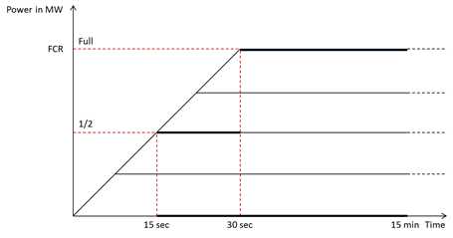
3.2.1.3 The technical parameters provided above are in line with the European provisions within the continental synchronous area. These could differ in some other synchronous areas, as illustrated in the table below.
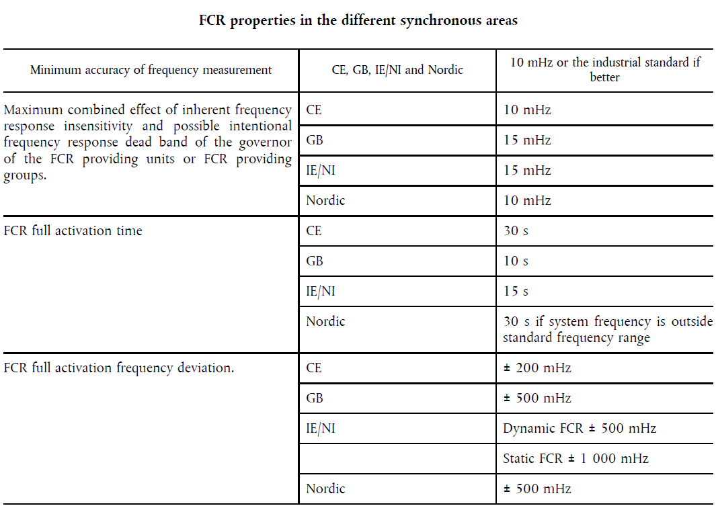

Prequalification tests
3.2.2.1 In the prequalification test, the BSP has to prove that it follows the technical requirement defined by the TSO. Herein, the TSO tests the technical unit or the pool of the BSP regarding the promising available capacity, as well as the capability to deliver the balancing electricity when the unit is activated. For this, the TSO demands two different prequalification tests, Synthetic Frequency Profile Test and Real Time Frequency Test.
3.2.2.2 The outcome of the tests will define the maximal balancing capacity that is allowed to be bidden FCRmax Ideally, the FCRmax value correspond to the reference value FCRref values declared by the BSP.

Synthetic Frequency Profile (SCF) test
3.2.3.1 The BSP’s pool or single technical unit must demonstrate a pre-defined reaction profile. the TSO prequalifies the technical unit or the pool of units in each direction (upward and downward). The tests in the two different directions can take place at different moments in time within a window of 24 hours.
3.2.3.2 The TSO will consider measurements on each technical unit requesting prequalification which are gathered via the real-time connection and apply the following rules:
- The minimal power value at each frequency step ∆f of 50 mHz (over a period of 120 seconds) will be taken as reference value FCR_{ref} for the related step;
- A 5 seconds margin is allowed in addition to the required activation time before the TSO considers the measurements to determine the minimal value of the step;
3.2.3.3 For this test, the TSO will calculate a P_{sup_prequal} (t) value as follows:
P_{sup_prequal}(t) = P_{measured}(t)-P_{ref_prequal}
Where:
- P_{ref_prequal}: The average power measured in the 20 seconds preceding the beginning of the test;
3.2.3.4 For the purposes of the test, the TSO will calculate 10 seconds average values of P_{sup_prequal}(t), called Av_ P_{sup_prequal}(t). To take into account the 5 seconds tolerance in the beginning of each step the TSO will calculate a 15 seconds average value at the beginning of each step instead of a 10 second average. Thus the TSO will select for each step the lowest (or highest for the downwards direction) value among:
- one average value of P_{sup_prequal}(t) over the first 15 seconds of the step after the 5 seconds tolerance and
- the remaining number of average values of P_{sup_prequal}(t) over 10 seconds for each step.
3.2.3.5 The outcome of this test is the FCR_{max _SFP} for each technical unit value which together with the outcome of the Frequency Real-Time Follow-Up Test will determine the FCR_{max}.
3.2.3.6 The technical unit must follow the following (indicative) profiles upward and downward following a step-by-step simulated frequency deviation:
- The technical unit must in 13 seconds (7,5 seconds of required activation time and 5 seconds of tolerance) deliver the volume of each step of 50mHz;
- The technical unit must maintain its reaction for 2 minutes before going to the next step of 50mHz.
- Once the technical unit has deployed its maximal supplied power, it must maintain its reaction for 22 minutes.
- The same reaction must be performed in the opposite direction as showed hereby above within 24 hours;
3.2.3.7 The TSO will calculate a value P_{step_min} as follows:
P_{step_min}=min(Min1; Min2; Min3; Min4; Min5; Min6; Min7; Min8)
Where:
- Min1= 4* ΔPsup_{Step_1} from t=13sec to t=128sec
- Min2= 4* ΔPsup_{Step_2} from t=141sec to t=256sec
- Min3= 4* ΔPsup_{Step_3} from t=269sec to t=384sec
- Min4= 4* ΔPsup_{Step_4} from t=397sec to t=1712sec
- Min5= -4* ΔPsup_{Step_5} from t=13sec to t=128sec
- Min6= -4* ΔPsup_{Step_6} from t=141sec to t=256sec
- Min7= -4* ΔPsup_{Step_7} from t=269sec to t=384sec
- Min8= -4* ΔPsup_{Step_8} from t=397sec to t=1712sec
Where:
- ΔP_{supstep}: The difference between the lowest (or highest for the downwards direction) Av_P_{sup_prequal}(t) during the step preceding the step concerned and the lowest (or highest for the downwards direction) Av_P_{sup_prequal}(t) value during the concerned step as mentioned hereby above.
- t=0 is the moment fixed as the beginning of the test for each direction;
3.2.3.8 The P_{step_min} value will be compared to the minimum power supplied (P_{full_up}; P_{full_down}) during the steps in which the BSP is expected to deliver his full reaction in the upwards and downwards direction as per profile described hereby above.
These values are calculated as follows:
- P_{full_up} (upwards direction): The lowest Av_P_{sup_prequal}(t) during the “Full Power_up” step. If this value is negative then P_{full_up} is considered equal to zero;
- P_{full_down} (downwards direction): The highest Av_P_{sup_prequal}(t) during the “Full Power_down” step. If this value is positive then P_{full_down} is considered equal to zero;
If :
P_{step_min} ≥ 0,9* min(P_{full_up} ; -P_{full_down})
then :
FCR_{max_SFP}= min(P_{full_up} ; -P_{full_down})
If not :
FCR_{max_SFP}= P_{step_min}

Real-time frequency test
3.2.4.1 The BSP will follow the frequency for xx consecutive hours, as if he was activated by the TSO for Service delivery after an auction.
3.2.4.2 The BSP can set the start time of the test at his convenience and communicates it to the TSO before the beginning of the test.
3.2.4.3 If during this interval one or several Frequency Variations superior to 40mHz occur, the TSO will check the largest of these Variations to see if the BSP has replied accordingly.
3.2.4.4 In case of a positive difference between the P_{req_act} for the test and P_{sup_act} for the said Frequency Deviation, the TSO will calculate a value as follows:
𝛥𝐹𝐶𝑅_{max_𝑅𝐹}=min(𝑃_{𝑠𝑢𝑝_𝑎𝑐𝑡}/𝑃_{𝑟𝑒𝑞_𝑎𝑐𝑡};1)
With
P_{sup_act} = max(P_{sup_after} − P_{sup_before}; 0) for upward direction and
P_{sup_act} = max(P_{sup_before} − P_{sup_after}; 0) for downward direction. Wherein,
P_{sup_before}: the average value of the summed power measurements (MW) of the technical unit over a period of 20 seconds starting exactly 20 seconds before the beginning of the frequency variation.
P_{sup_after}: the highest value (for upward)/ lowest value (for downward) of the summed power measurements (MW) of the technical unit in a period of 30 seconds starting at the moment when the frequency variation reaches its maximum value.
P_{req_act} = Abs(P_{req_before} − P_{req_after})

Calculation of FCR_{max}
3.2.5.1 The FCR_{max} value that a technical unit of the BSP can be prequalified to deliver to the TSO is calculated as follows:
3.2.5.2 The FCR_{max} value that a BSP can deliver to the TSO is calculated as follows:
FCR_{max} =min[FCR_{ref};FCR_{max _SFP}∗ΔFCR_{max _RFT}]
Where:
- FCR_{Ref} : Reference value provided by the BSP
- FCR_{max _SFP}: Value calculated as mentioned hereby above for each technical unit as a result of the Synthetic Profile Test;
- ΔFCR_{max_RF}: Value calculated as mentioned hereby above for each technical unit as a result of the Follow-up of Real-Time Frequency test;

aFRR provider qualification

Technical criteria
3.3.1.1 In the following table, the technical specifications for the aFRR availability commitment are listed.
Availability committed capacity size requirement (minimum size of bid per unit) | ± x MW
Availability committed capacity size requirement (maximum size of bid per unit) | ± x MW
Activation duration | at least 15 consecutive minutes
First observable power change | At least within 10 seconds after a setpoint change
Full activation and deactivation time | Full activation after max. 7,5 minutes
Maximal short-term overshoot | 10% of the bidden aFRR volume, but not more than 1 MW
Accuracy | Deviation shall be smaller than 7.5% only two deviations are allowed for each 10 seconds measurement window

Prequalification test
3.3.2.1 In order to attest a technical unit to participate in a specific service it must successfully pass a prequalification test. In this, the BSP demonstrates that the technical unit is capable to follow the ramping requirements as presented in the figure below. Moreover, the BSP proves that the technical unit can deliver the energy for at least 15 minutes consecutively.
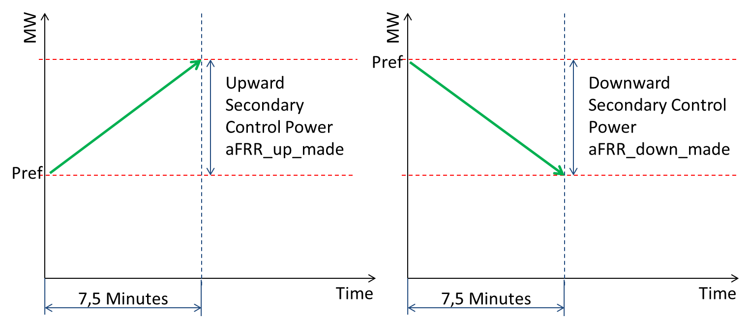
3.3.2.2 In case the Production Unit does not complete the simulation test successfully, the TSO and the BSP will make best effort to identify the source of the failure and the BSP will make best effort to solve the source of the failure.
3.3.2.3 For the simulation of aFRR, the BSP must simulate the following activation signal. With this signal the TSO will test whether the BSP can activate aFRR of the Production Unit and if he is able to follow a variable signal with a deviation smaller than 7.5% of the maximum value (2 deviations of 10 seconds allowed). This test will take 100 minutes. For this test a sample will be taken every 10 seconds (starting at 00:00:00 , 00:00:10:...). This signal must be between the upper and lower accuracy limit (band of 15%) as indicated in the figure below.
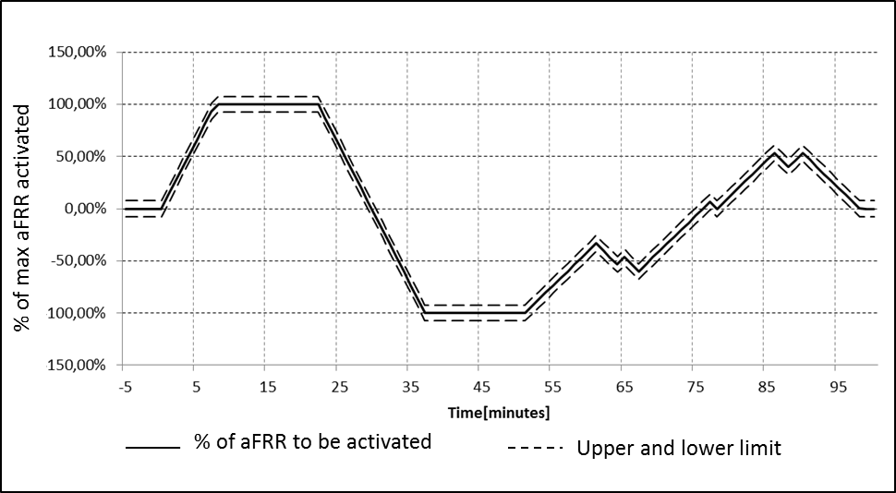
3.3.2.4 Requirements for attestation:
- Does the aFRR Supplied reaches the maximum as indicated in max increment?
- Is the deviation smaller than 7.5% (2 deviations of 10 seconds allowed)?

mFRR/RR provider qualification

Technical criteria
3.4.1.1 In the following table, the technical specifications for the aFRR availability commitment are listed.
Availability committed capacity size requirement (minimum size of bid per unit) | ± x MW
Availability committed capacity size requirement (maximum size of bid per unit) | ± x MW
Full activation and deactivation time | within 15 minutes
Activation duration | The TSO may continue activation of this reserve as long as it is bid.

Prequalification test
3.4.2.1 Technical units which passed the prequalification test in the previous year and have provided subsequently mFRR/RR to the TSO are considered to be prequalified unless the TSO withdraw their prequalification due to subsequent non-compliance. Otherwise, a technical unit must be prequalified before it can be part of a contract.
3.4.2.2 In order to attest a technical unit to participate in the mFRR/RR capacity auction, it must successfully pass a prequalification test by demonstrating its capability to fulfill the technical requirements as stated above. The prequalification test is required for production -, as well as offtake reserves in terms of Demand Response (e.g., large industrial production plants). The technical criteria for both providing unit type are the same.
3.4.2.3 The outcome of the test will define the maximal mFRR and/or RR power that the BSP may offer to the TSO.
3.4.2.4 For the simulation test of (direct activated) mFRR, the BSP must demonstrate an activation of mFRR. The technical unit (production or demand) must activate the maximum mFRR within 15 minutes.
3.4.2.5 Requirements for the prequalification test mFRR max must be attained within 15 minutes (ramp-up).
3.4.2.6 The technical unit must be able to return to its original program within 15 minutes (ramp-down)

ER provider qualification
3.5.0.1 This product is not standard, and is not likely to be applicable in the mid-term, however this could be considered by the TSO in the future in case of scarcity volume of mFRR from generation assets which can be contracted to cover the dimensioning requirements and/or as a back-stop for the market failing to timely activate replacements for outages. This will also depend on the availability of demand facilities capable of providing such services.

Technical criteria
3.5.1.1 The BSP shall complete and submit a description of the power consumption units from which the service will be provided. The details of requirements depend on the nature and the availability of interested demand facilities in providing such services. As a reference, we include the provisions currently applicable in Germany, where the description includes: the construction, the function and operating mode, and the resulting electrical load characteristics of the unit. Furthermore, the BSP shall describe its consumption unit ramp-down process, the following ramp-up process, and other important operational constraints. The BSP shall declare also the minimal and maximal technically feasible load interruption duration.
3.5.1.2 The BSP shall name the physical location and the connection point of the consumption unit. The connection point shall be defined during the prequalification and cannot be changed.
3.5.1.3 The minimal installed capacity of the demand unit shall be at least xx MW. It needs to have forecastable load behaviour. The minimal and maximal value for each capacity bid in the yearly tender process is 3 MW and 50 MW, respectively.
3.5.1.4 The consumption unit has to fulfil certain requirements on its loading characteristic. The variation of the actual power consumption curve is allowed to run in a certain range after the demonstrated activation. This range is oriented on the expected minimal power consumption curve of the unit which is designated as the lower limit of the range. The upper limit of the range is calculated as the expected minimal power consumption plus 20% of the awarded emergency reserve. The minimal full activation duration is 15 minutes. The full activation time may not be more than 10 minutes.
3.5.1.5 The BSP shall confirm that the emergency reserve capacity is available at every single quarter-hour, but limited to x times per day, y times per week, z times per year. X, y and z can be specified by the BSP and must be agreed during the negotiated tender procedure for this specific product. Minimum values of x, y and z need to be specified by the TSO and likely to be a result of the negotiations.

Prequalification test
3.5.2.1 The prequalification for emergency reserves shall be an integral part of the tendering process for that product. Technical requirement could be fixed depending on the available and possible services that could be provided by Albanian demand facilities.
3.5.2.2 The BSP has to prove that the load interruption is completed with the full prequalified load interruption capacity within a full activation time after the delivery start remotely commanded by the TSO. The load reduction shall start (almost) instantaneously (e.g. within 1 second, to be negotiated).

Fall-back
3.6.1. A prerequisite to start the ABM shall be that sufficient technical units are qualified. Shall this not be the case then a dialogue with the industry and ERE will be required to seek solutions: delay of the start in order to allow new investments towards more pre-qualified volumes, reduce the amount to be contracted, i.e. more relying on uncontracted bids, engage with neighbouring TSOs on cross-border reserve sharing (only works if there is unused capacity in importing direction on at least one border all the time, not necessarily the same border), engage with demand side on demand side response in case of emergency (emergency reserves as a substitute for mFRR). The way to go forward will depend on the situation with respect to generation investments, cross-border availability of reserve, willingness of industry and cross-border TSOs, ERE and the costs.
3.6.2. The TSO has been requested to provide a complete list of technical units connected to the Albanian TSO and DSO network to verify availability of adequate volumes of FCR, aFRR and mFRR as well as potential volume of demand side response to substitute mFRR from generators. This list should inform feasibility of the start of the ABM and/or alternative measures needed. The analysis of this list and the discussion of alternative approaches if needed is in scope of the implementation phase.

AVAILABILITY COMMITMENT PROCESS.

Participant registration and mutation process
4.1.1 The TSO shall announce the tender and invite interested parties for an Expression of Interest.
4.1.2 Interested parties shall file an Expression of Interest with:
- Product for which availability can be guaranteed
- In case the interested party did not yet qualify as a BSP to tender for a capacity contract:
  - The volume on which availability can be guaranteed and how it can be guaranteed
  - Proof of access to connected assets from which the service will be provided
  - Declaration of acceptation of the contracting terms and conditions
- In case the interested party is a qualified BSP to tender for a capacity contract, the BSP concerned.
4.1.3 The TSO shall invite all parties that have submitted a complete EOI but that are not yet a qualified BSP for the tender, to prequalify as a BSP.
4.1.4 The TSO shall register all parties that have submitted a complete EOI that have also qualified as a BSP to participate in the tender.

Dimensioning and sizing

FCR
4.2.1.1 For FCR, the dimensioning requirements are according to ENTSO-E, Operational Handbook CE, Policy 1.
4.2.1.2 The TSO shall publish the argumentation for the required volumes of FCR to be contracted.
4.2.1.3 The dimensioning shall be carried out at least once a year. All capacity resulting from the dimensioning shall be contracted. The TSO shall strive for a common platform for contracting of FCR with neighbouring TSOs. The amount of FCR that can be exchanged (contracted outside LFC control block of Albania by the TSO or contracted by neighbouring TSOs in Albania) is limited by ENTSO-E rules.
4.2.1.4 As a member of ENTSOE, the TSO also takes part in the common FCR dimensioning and operation. According to ENTSO-E, the total needed FCR volume in the UCTE synchronous area is 3000 MW. By distributing this amongst the countries according to the ratio of the electricity generation in each control area to the total electricity generation in the UCTE synchronous area, the TSO’s obliged FCR volume is around 6 MW. A minimum share of the volume (30%) shall be contracted directly within the TSO’s control block.

aFRR
4.2.2.1 Every year, the TSO determines the dimensioning requirement for aFRR on the basis of the formula: Minimum aFRR = Sqrt (10 x Lmax + 22500) – 150
In this formula Lmax is the maximum anticipated consumer load for the Albanian control area for the coming contracting period, i.e. one year. Lmax is to be set by the TSO. As an example, with a reported winter peak load of 1400 MW in 2011, the minimum amount of aFRR to be procured will be set at about 42 MW. The dimensioning requirement is bidirectional, i.e. the resulting amount shall be contracted in both up- and downward direction.

mFRR
4.2.3.1 For upward mFRR, a volume equal to the largest single generating unit that can be online at any time during the year is required. The largest generating plant in Albania is the Komani power plant which has several units of which the largest is about 150 MW of installed capacity. It shall not be necessary to contract the complete 150 MW of mFRR reserves. The contracted amount of aFRR can be subtracted from it and for the remaining required upward mFRR, a part may be bid on a voluntary basis and a part may be provided by emergency contracts with neighbouring TSOs. For relying on voluntary bids, emergency reserves can be contracted to cover for any risks of insufficient volumes while at the same time providing an incentive to the market to offer more.
4.2.3.2 For emergency contracts with neighbouring TSOs it shall be considered that Albania is a transit country and there shall always be import capacity available with at least one TSO and export capacity available with another TSO.

RR
4.2.4.1 Replacement of generators after a forced outage is a market responsibility. Therefore, there are no dimensioning requirements for RR as the TSO shall not need RR.

Emergency reserves
4.2.5.1 There are no dimensioning requirements on emergency reserves as such. Any amounts that are missing from aFRR, mFRR and balancing reserve exchange contracts with neighbouring TSOs plus the amount of voluntary bids that can be relied on, sets the need for emergency reserve contracts. Best practice experiences elsewhere show that for some large electricity consuming industries adjustment of their production processes to allow for remote instructed demand reduction is quite feasible for a reasonable price and this potential shall therefore also be explored in Albania.

Bidding process
4.3.1 In the bidding process for the contracting of required capacities only registered participants for a given product may bid. Bids for a capacity contract shall be specified as:
- Offering party;
- Capacity product offered (FCR, aFRR or mFRR);
- Volume offered (MW);
- Price offered (€/MW). Note that this is the price per MW for guarantee of available volume of the product over the entire contracting period. Divided by the hours in the contracting period, this gives the price per MW and per hour;
- End of availability commitment period if this is before the end of the contracting period.
4.3.2 The above primarily applies to aFRR and mFRR capacities which will be procured through weekly auctions. For FCR an annual auction is initially foreseen which may develop into a weekly auction eventually. For emergency reserves, an annual negotiated tender process is most suited.
4.3.3 TSO may reject a bid which does not cover the entire availability commitment period or may consider a break-up of the commitment period.

Selection process
4.4.1 The total amount of upward aFRR + mFRR to be contracted is equal to the dimensioning requirement for upward aFRR plus the amount remaining from the dimensioning requirement of upward mFRR after subtraction of volume of voluntary bids that may be expected and the volume that can be exchanged under mutual assistance contracts with neighbouring TSOs. The minimum amount of upward and downward aFRR to be contracted is equal to the aFRR dimensioning requirement.
4.4.2 For each product, for each hour in the contracting period, bids that have offered availability for that hour shall be selected in bid price merit order until the required volume is reached or until the budget limit is reached. Bids may only be selected for the entire contracting period.
4.4.3 If the budget limit is reached before the required amount is reached, raising of the budget shall be considered. If there are no more bids that cover the entire contracting period and the required amount is not reached, but bids that offer limited duration of availability would supplement the required amount, there are two considerations: either additional bids are in a new tender contracted for a shorter time period, or the TSO relies on voluntary bids that supplement the required volumes.

Pricing
4.5.1 All capacity bids are paid as bid. BSPs receive a remuneration based on contracted capacity times the contracted bid price per MW over the whole contracting period, or per MW per hour of the contracting period.

Results publication
4.6.1 Results of a tender shall be published before the delivery commitment process starts. Such publishment consists on publication of:
- Requested Product;
- Total volume offered;
- Lowest bid price, highest bid price;
- Total volume awarded;
- Average volume weighted bid price of awarded volume; and
- Highest bid price of awarded volume.

Timings
4.7.1 FCR tenders to be performed initially on an annual basis.
- Call for Expression of Interest: 13 weeks ahead of the day of start of delivery
- Closing of EoI period: 11 weeks ahead of the day of start of delivery
- Gate opening for tender: 10 weeks ahead of the day of start of delivery
- Gate closure for tender: 8 weeks ahead of the day of start of delivery
- Results publication deadline: 6 weeks ahead of the day of start of delivery.
4.7.2 aFRR and upward mFRR tenders to be performed initially on a weekly basis.
- Call for Expression of Interest (first auction): 13 weeks ahead of the day of start of delivery
- Closing of EoI period (first auction): 11 weeks ahead of the day of start of delivery
- Gate opening for auction: 10 weeks ahead of the day of start of delivery
- Gate closure for auction: 2 working days ahead of the day of start of delivery
- Results publication deadline: 1 working day ahead of the day of start of delivery.
4.7.3 Timings shall give TSO reasonable time for decision making and market parties reasonable time for preparation towards the next phase. Final timings shall be agreed in dialogue with market parties. Timings shall also be aligned with timings for prequalification.

Fall-backs
4.8.1 In case of failure of auction for whatever reason, the following options shall be considered:
4.8.2 A prerequisite to start the ABM shall be that sufficient technical technical units are qualified. Shall this not be the case then a dialogue with the industry and ERE will be required to seek solutions: delay of the start in order to allow new investments towards more pre-qualified volumes, reduce the amount to be contracted, i.e. more relying on free bids, engage with neighbouring TSOs on cross-border reserve sharing (only works if there is unused capacity in importing direction on some border, not necessarily the same border all the time), engage with demand side on demand side response in case of emergency (as a substitute for mFRR). There is no prescription for this process in general as the way to go forward will depend on the situation with respect to expansion planning, cross-border availability of reserve, willingness of industry and cross-border TSOs, ERE and last but not least, the costs.
- If not enough volume can be procured with the first auction, the TSO should consider announcing requests for more bids in a second round of the same auction, e.g. on the next day. The precise timing needs to be discussed and agreed with the industry as they shall have the possibility to increase the volume of bids or adapt their bid prices;
- If the tender fails due to technical issues, the issue shall be solved and the tender repeated after successful resolution of the failure.Depending on the reason for failure, the tender timings could be adapted to allow for resolution of the problem.
4.8.3 If at the end of the day still not enough volume can be contracted, ad-hoc measures shall be considered. For example emergency contracts with neighbouring TSOs or the demand side. In this case the imbalance price when these contracts are activated shall be high enough as a disincentive for the market to rely on the TSO, e.g. a surcharge of 25% on the activation price of the most expensive balancing energy bid.

DELIVERY COMMITMENT PROCESS

Bid specification

Bid categories

5.1.1.1 All delivery commitment bids for aFRR, mFRR and RR belong to one of the following:
- Balancing purposes:
  - Bids aFRR contracted;
  - Bids aFRR not contracted;
  - Bids mFRR/RR.
- Other purposes (e.g. congestion management):
  - Bids RR.

Structure of a delivery commitment bid message
5.1.2.1 A BRP offering on behalf of a BSP, can send more than one delivery commitment bids in a single bid message. A bid message has three layers:
- The bid message
- The bid (0..n per bid message)
- Bid lines (92..100 per bid)
5.1.2.2 The bid message is composed by an (unlimited) number of bids. A bid message with number of bids nil (0) indicates the BRP does not want to submit any delivery commitment bids.
5.1.2.3 Each new bid message sent overrules all previous bid messages.
5.1.2.4 The bid messages are exchanged in a standardised format. the TSO shall define and make this standard available to all parties. The TSO shall publish a detailed description of this format.
5.1.2.5 The bid message is sent by the BRP to the central mailbox system of the TSO, and shall be addressed to the contact person defined by theTSO.
5.1.2.6 Each delivery commitment bid aFRR/mFRR/RR is composed of bid lines, one for each ISP (clock quarter of an hour). Any normal day counts 96 ISPs.

Attributes of a bid message
5.1.3.1 Attributes of a bid message are presented in the following table:
Attribute | Unit | Description | Permissible values
BSP | N/A | Identification of the BSP | EIC code
BRP | N/A | Identification of the BRP whose imbalance will be adjusted on activation | EIC code
Request | N/A | If the message is submitted at TSO’s request, the TSO-issued request number must be included | TSO-issued request number
Date of delivery | N/A | The date for which the bids are valid | Date in the range: current to current + 7 calendar days

Attributes of a delivery commitment bid
5.1.4.1 Attributes of a bid message are presented in the following table:
Attribute | Unit | Description | Permissible values
Agreement | N/A | Identification of the agreement between the BSP and the TSO | TSO-issued contract number comprising 10 alphanumerical characters
Reference | N/A | Bidder-issued unique identification of the bid as part of the message | bidder’s choice
Object¹ | N/A | An object enables a bidder to couple two bids. From an Object only one bid can be activated at the same time | bidder’s choice
Activation time | ISP | Minimum ISP interval relative to current for which Bid is available to be activated by TSO; distinguishes aFRR, mFRR/RR for balancing, mFRR/RR for other purposes | Integer value in the 0 to 672 range (7 days)  aFRR (contracted/not contracted): Activation Time = 0;  mFRR Balancing: Activation Time = 1;  RR for balancing: Activation time = 2, 3, 4;  RR for other purposes: Activation Time ≥ 5
Activation Duration | ISP | Minimum number of consecutive ISP's for admissible activation by the TSO | Integer value 1 or in the range 0 to 672 (7 days)  aFRR (contracted/not contracted), mFRR/RR for Balancing: Activation Duration = 1;  RR for Other purposes: Activation duration ≥ 4
Volume | MW | Bidsize:  + upward  - downward | Upward: Integer in range 4 to 200;  Downward: Integer in range -4 to - 200
Regulation rate | % per minute of bid size (attribute “Volume”) | Regulation rate, as percentage of attribute “Volume” per minute | One decimal place, value in the range 7.0 to 100.0
Location/Grid object | N/A | A connection, or set of connections, within the Albanian high-voltage grid, from which BSP will dispatch on activation. This connection or set of connections belongs to one owner or administrator. | EIC code
- An aFRR object couples two bids of opposite sign (upward/downward); A mFRR/RR object for other purposes couples two bids with similar bid size and activation time, but with different activation duration and price.

Attributes of a delivery commitment bid line
5.1.5.1 Each ISP on the date of delivery for which the bid is available must be specified.
Attribute | Unit | Description | Permissible values
Availability | ISP | ISP number for which bid applies | Unique Integer value in range1 1 to 100, ascending
Bid price | €/MWh | Balancing energy bid price | Two decimal places  Value in the range  -10,000.00 to +10,000.00

5.1.5.2 For bids for balancing purposes the bid price may vary per ISP; for bids for other purposes the bid price must be constant.
5.1.5.3 The symbol (sign) of the product of the bid size and the BSP balancing energy activation price denotes the direction of the cash flow, with + indicating that the TSO pays the BSP and -, that the BSP pays the TSO.If Volume = 0, the bid price does not apply.
5.1.5.4 The symbol (sign) of the bid and the activation price derived from the bid prices of all activated bids dictate the direction of the cash flow:
 | Activation price >0 | Activation price <0
Upward balancing energy | TSO pays BSP | BSP pays TSO
Downward balancing energy | BSP pays TSO | TSO pays BSP

Optional aspects of attributes
5.1.6.1 The table below defines which attributes are optional and which are mandatory, depending on the bid category:
Bid category  Attribute | aFRR  Contracted | aFRR  Not contracted | mFRR/RR  Balancing | RR  Other purposes
BSP | Mandatory | Mandatory | Mandatory | Mandatory
ISP | Mandatory | Mandatory | Mandatory | Mandatory
Request | Optional | Optional | Optional | Optional
Date of delivery | Mandatory | Mandatory | Mandatory | Mandatory
Contract | Mandatory | N/A | N/A | N/A
Reference | Mandatory | Mandatory | Mandatory | Mandatory
Object | Optional | Optional | N/A | Optional
Activation time | Mandatory | Mandatory | Mandatory | Mandatory
Activation duration | Mandatory | Mandatory | Mandatory | Mandatory
Regulation rate | Mandatory | Mandatory | N/A | N/A
Location | Mandatory | Mandatory | Mandatory | Mandatory
Volume | Mandatory | Mandatory | Mandatory | Mandatory
Bid price | Mandatory | Mandatory | Mandatory | Mandatory

Bidding gate closures

Before the day of delivery
5.2.1.1 The balancing energy bids for the day of delivery are required to reach the TSO by 14h00 daily on the day prior to that of delivery. aFRR/mFRR/RR bid messages received by the TSO between 14h00 and the time of approval by the TSO that have not been provided with a valid Request number will be ignored (on notification of the sender).
5.2.1.2 As soon as the time of approval by the TSO has passed, the aFRR/mFRR/RR bids for the day of delivery can be revised. The procedure for the day of delivery comes into operation at 23h00 on the day of preparation.

During day of delivery
5.2.2.1 On the day of delivery, the deadline for submitting revised aFRR/mFRR/RR bids always closes one hour ahead of each ISP. After bidding gate closure for an ISP all bids for that ISP are rejected except those that have a Request number issued by the TSO.
Example: It is 18h42 and a BSP decides to revise its bids for the current day. At this time the BSP will be permitted to submit changes for the ISP from 19h45 to 20h00 and all further ISPs. In the event of the BSP submitting changed bids for one or more ISPs before 19h45, its bid message with all its bids will be rejected.

Results publication
5.3.1 The TSO shall publish a merged bid merit order for balancing purposes and for other purposes separately in an anonymized form. This merged bid ladder can be requested at any time for the next day and for any day before that. When showing, request date and time and the day of delivery shall be displayed.
5.3.2 Publication of an anonymized merged bid merit order has the following advantages:
- BSPs can use it to (re)-position their bids or to post new bids
- To a lesser extent, BRPs can base their assessment of imbalance risk on this information and act on the intraday market accordingly, however:
  - Bids are not firm until final gate closure
  - It concerns a merged bid ladder of aFRR and mFRR bids while in practice aFRR bids may occasionally get activated before mFRR bids, even if they are more expensive (for technical reasons)
5.3.3 The anonymized merged bid merit order would show the balancing energy price at different levels of activated volumes, e.g. at 50 MW, 100 MW, 200 MW, 400 MW and 100% of total volume available in both directions (upward and downward).

Timings
5.4.1 This is a summary of the timings already provided above:
- Gate opening for delivery commitment bidding: D-7, 0h00
- Initial gate closure for delivery commitment bidding for all ISPs of day D: D-1, 14h00
- Approval of initial bids by the TSO and re-opening of bidding gate for all ISPs of day D: D-1, 15h00
- Final gate closure for delivery commitment bids of ISP i (i=0-100) on day D: D, 1 hour before start of ISP i.

Note that this attribute could also be specified as Full Activation Time (FAT) in minutes, the regulation rate can then be derived from: ramp rate = 60/FAT [%/min]

